**Saransh**

**2020070**

**Problem 1**

The above graph represents revenue generated by categories for male and female. We can see from the above image that Mobiles & Tablets have a significant impact on revenue, with females contributing more than males after that it is followed by the Appliances, for which both male and female contributed to the same amount.

**Problem 2**

I used the geographical plot to represent the data in the above plot. In this figure, the data is represented as a glyph, and the color represents denser glyphs. The graph represents revenue in the United States by state, and we can see from the graph that the highest revenue earned is 15.5 million, followed by 13.9 million, 9.1 million, and finally 8.5 million.

orders per category by gender

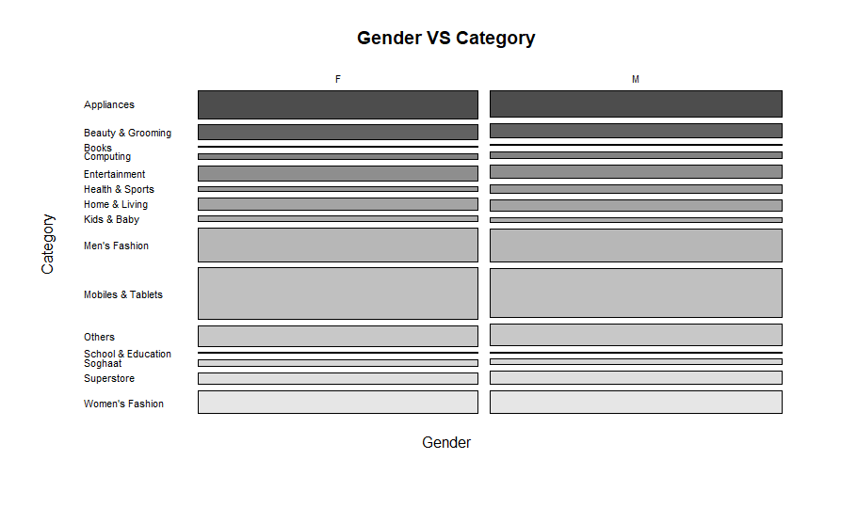

* Highest number of orders are from Mobiles and Tablets category
* The categories books and school-education have the least number of orders.
* Females placed more orders in mobiles and tablets, appliances and home and living categories.
* Males have placed more orders in books, computing and health and sports categories.